# Django-Auth0-App - Project Setup Guide

This guide provides step-by-step instructions to clone, set up, and run the Django-Auth0-App from the GitHub repository: https://github.com/saidigitalcode/Django-Auth0-App

## Prerequisites

Make sure you have the following installed:

* - Node.js (v14 or higher)
* - Python 3.8 or higher
* - PostgreSQL or any compatible database (if using DB)
* - Git

## Step 1: Clone the Repository

Run the following command to clone the repository:

git clone https://github.com/saidigitalcode/Django-Auth0-App

## Step 2: Setup Backend (Django)

1. Navigate to the backend directory:

cd Django-Auth0-App/backend

2. Create a virtual environment and activate it:

python -m venv venv  
venv\Scripts\activate (Windows)  
source venv/bin/activate (Linux/Mac)

3. Install the required packages:

pip install -r requirements.txt

4. Create a `.env` file and set environment variables (AUTH0_DOMAIN, API_IDENTIFIER, etc.).

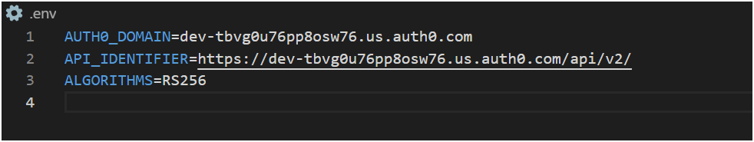

Taking from Auth 0:

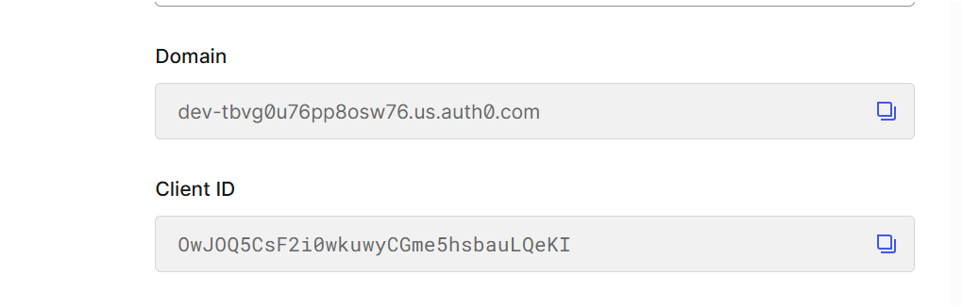

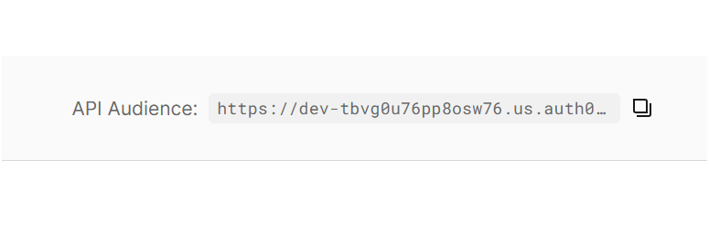

5. Run the Django server:

python manage.py migrate

python manage.py runserver

## Step 3: Setup Frontend (React)

1. Navigate to the frontend directory:

cd ../frontend

2. Install the dependencies:

npm install

3. Create a `.env` file with the following keys:

Taking from Auth 0:

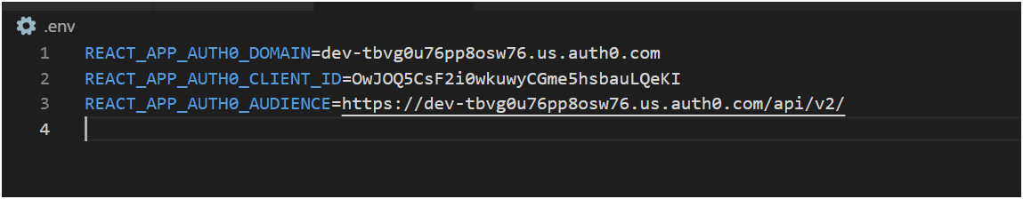





REACT_APP_AUTH0_DOMAIN=your-auth0-domain  
REACT_APP_AUTH0_CLIENT_ID=your-client-id  
REACT_APP_AUTH0_AUDIENCE=your-api-identifier

4. Start the React development server:

npm start

## Step 4: Usage

1. Open http://localhost:3000 to access the frontend.  
2. Use the 'Continue with Google' button to log in.  
3. After login, click 'Get the details to verify token and access backend.